Methods
Study design
This study was designed as a retrospective observational study carried out at the medical faculty of Ulm in Baden-Württemberg/Germany between July 2022 and July 2023.
Medical students at Ulm university are enrolled in a lecture and a consecutive seminar on clinical pharmacology, which extend over one semester each and both conclude with a written exam. As part of the regular curriculum, Students are assigned to either of two groups and will be enrolled in the lecture either in the seventh or in the eight semester, and in the seminar in the subsequent semester.
Examinees of three seminar exams (seminar 2022, seminar 2022/23, and seminar 2023), and examinees of two lecture exams (lecture 2022, lecture 2022/23), in total 820, were invited to participate in the study. The number of individual students is lower, since many examinees of the lecture exams for 2022 and 2022/23 did later participate in the seminar exams of 2022/23 and 2023 respectively.
The exams are single best answer tests consisting of 40 (lecture) or 30 (seminar) test items each with five options per item. Each correct item yields one point. Passing both exams as well as attending the seminar are mandatory part of the curriculum, while lecture attendance is optional.
At the beginning of the lecture and of the seminar, students were made aware of the option to use Anki flash cards for studying, which were available for download on the course material website. Also available were a brief manual (detailing installation of the most up-to-date Anki version and importing, creating, and editing cards), as well as an FAQ.
Anki cards creation and structure
Anki is an open-source flashcard software available for most desktop and mobile platforms. Anki allows users to study material following a spaced repetition algorithm, in which the interval until next review of a card is determined by the learner’s self-rated confidence of correct recall. Cards in which recall is rated as difficult are scheduled for earlier repetition, and cards which were more easily remembered reoccur after a longer interval. Content for Anki can be downloaded from a free and user-generated online repository or created by end-users themselves.
Anki cards for 226 drugs had been created by institute staff and were based on the 2021 version of the IMPP Arzneistoffliste (IMPP, 2021). The Arzneistoffliste defines key drugs and serves as an official guideline for the pharmacology-related items of the centralized written German medical licensing examinations.
Cards were organized in distinct decks according to medical fields, and further divided into two decks for each field:
- A basis deck showing the drug name on the front, and on the back either the effect, the mechanism of action, indications, contraindications, or side effects
- A comprehensive knowledge deck, showing the drug name on the front and extended drug information on the back.
Information on the back was mostly presented as bullet lists or single terms, and occasionally short texts or diagrams when appropriate. Cards were tagged for efficient filtering in Anki, including a tag for those cards considered relevant for the exam concluding the lecture and the seminar.
Other studying materials made available to students were lecture and seminar slides, comprehensive electronic scripts accompanying the lecture, example questions, case tasks and exercises as part of our e-learning repository, and textbook recommendations. Students were free to download external Anki decks or create their own.
Questionnaire
Immediately after both the lecture and seminar exam, students were handed survey questionnaires. The questionnaires comprised 11 items for the seminar 2022 cohort, while the other four cohorts (lecture cohort 2022/23, seminar cohort 2022/23, lecture cohort 2023, and seminar cohort 2023) were given an extended questionnaire of 22 items for providing comprehensive insights into their Anki-usage.
Students were asked which learning strategies they employed and considered useful, whether and to what extent they used Anki for exam preparation and their attitude towards Anki, as well as basic demographic information. Those who did not use institute-provided Anki cards were asked to select a reason. Participants were also asked to rate their academic performance in general, and in clinical pharmacology in particular, on a five-point ordinal scale. Since exam scores in other subjects were not available to us, self-assessment of academic performance served as a proxy.
Students explicitly consented to data processing.
Students generate a pseudonymous code as part of routine exam procedure to write on their response sheet before handing it in. For this study, they were invited to voluntarily provide their code on the survey questionnaire as well, allowing us to pseudonymously associate survey questionnaires with exam results.
Statistics
For descriptive statistics, exam scores were transformed into percentages of maximum scores. For inference statistics, exam scores were z-standardized within each cohort before pooling to account for differing exam difficulty.
Differences in categorical variables were assessed using chi-square tests, and ordinal variables were compared between groups using Wilcoxon rank-sum tests.
To investigate whether exam performance differed between Anki users and non-users, we first fitted an unadjusted linear regression model with exam score as the dependent variable and Anki use as the independent variable. We then fitted an adjusted model including self-rated academic performance as a covariate to account for potential confounding by general academic ability. Since not all students gave a self-assessment of their performance, the unadjusted linear regression was repeated with a dataset restricted to students who provided self-assessment.
For all regression analyses, students with missing data on relevant variables were excluded from the respective models. Statistical significance was set at p < 0.05.
All other inference statistics were done using correlations reporting Spearman's ρ.
Statistical analysis was performed in R version 4.4.1 (R Core Team, 2024), using the package ggplot2 (Wickham, 2016) for figures.
Offene Fragen Methodenteil:
- Alle Beobachtungen wurden als unabhängig gewertet, auch wenn die Stud. evtl. in einer späteren Kohorte auftauchen. Soll ich das beschreiben und begründen? Oder soll ich die Statistik wiederholen und die Beobachtungen als zum Teil abhängig betrachten? Dann müsste ich mich schlau machen, wie das geht, weil das ja die erste Kohorte gar nicht betrifft, und in den übrigen Kohorten nicht alle Stud.
- In einigen ähnlichen Papers wird erwähnt, dass kein Ethics approval notwendig war. Soll ich auch so etwas schreiben?

Results
Out of 920 participants in the exams, 820 (89.91%) returned the survey questionnaire, consented to data processing, and filled in their pseudonymous code to pair survey data with exam scores (Table 1). The mean percentage of
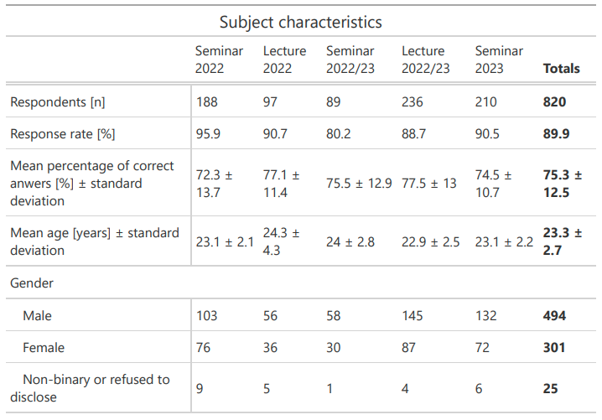
Table 1. Demographic and response characteristics of the study population.
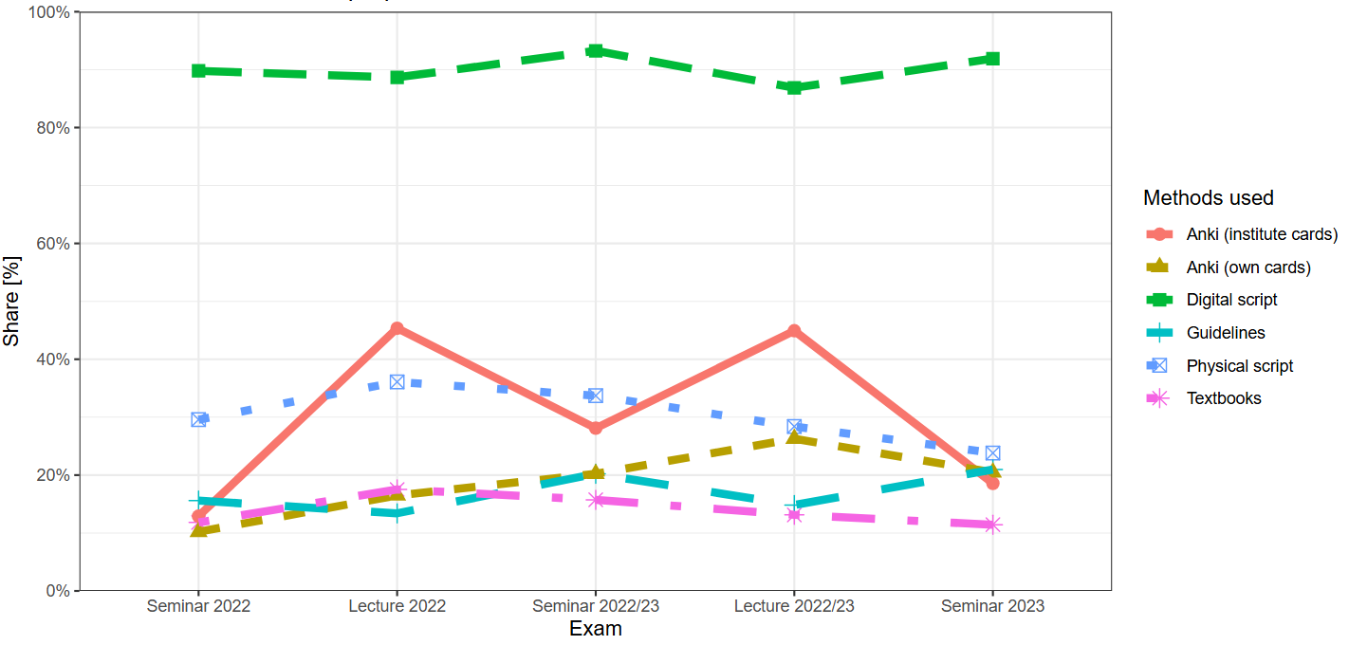
Figure 1. Methods used for exam preparation by cohort.

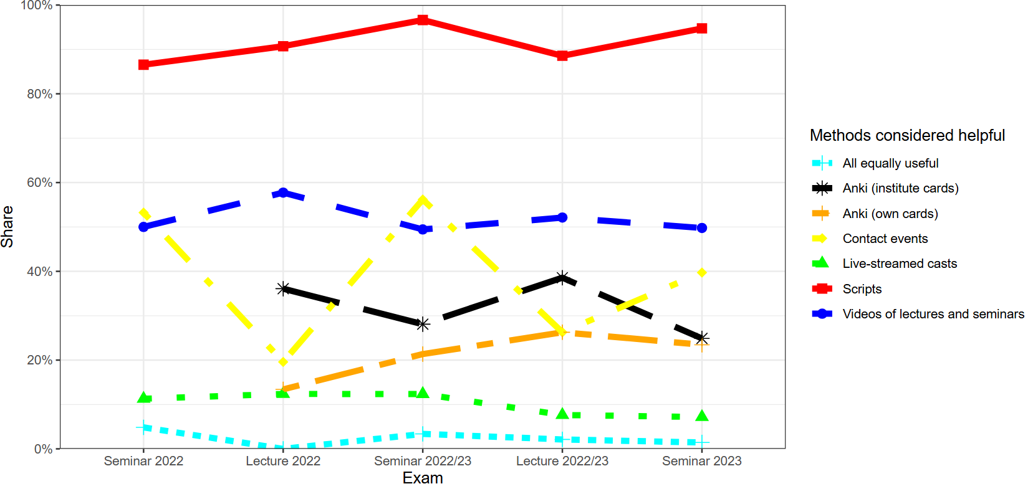
Figure 2. Methods considered helpful for exam preparation by cohort..
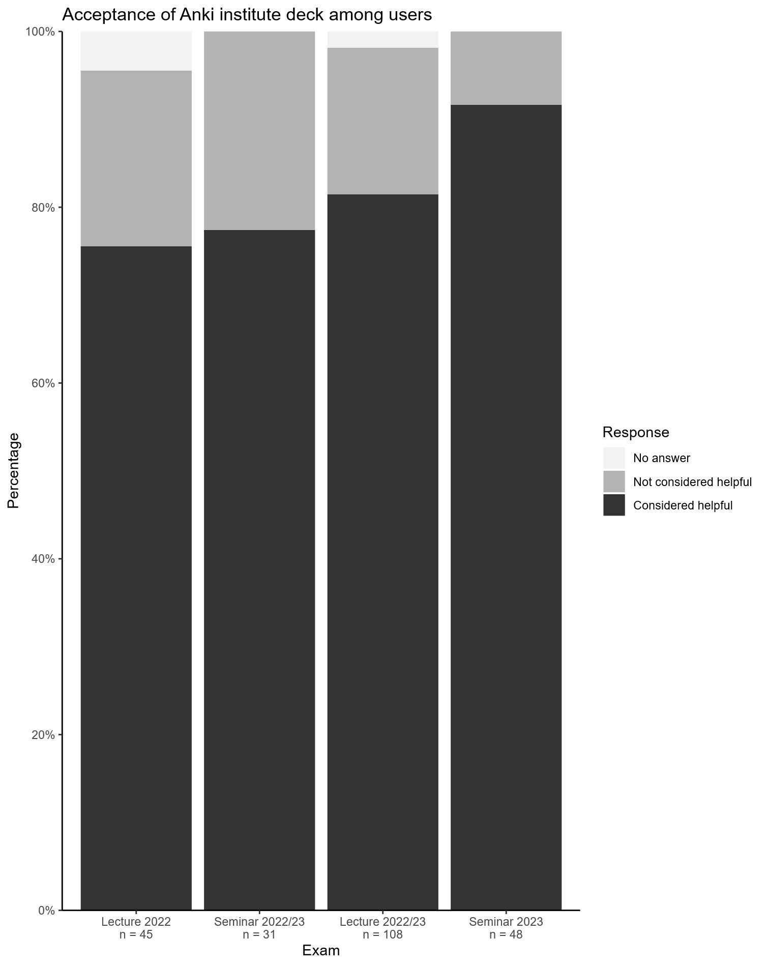
Figure 3. Perceived usefulness of Anki for exam preparation.

Conclusions

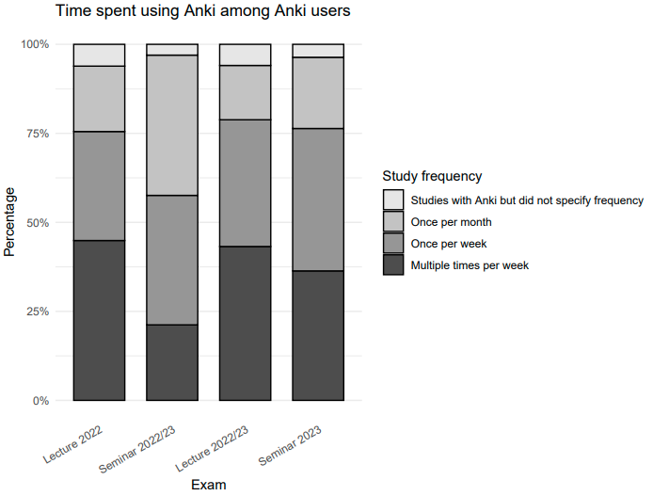
Figure 4. Frequency of Anki usage by cohort.

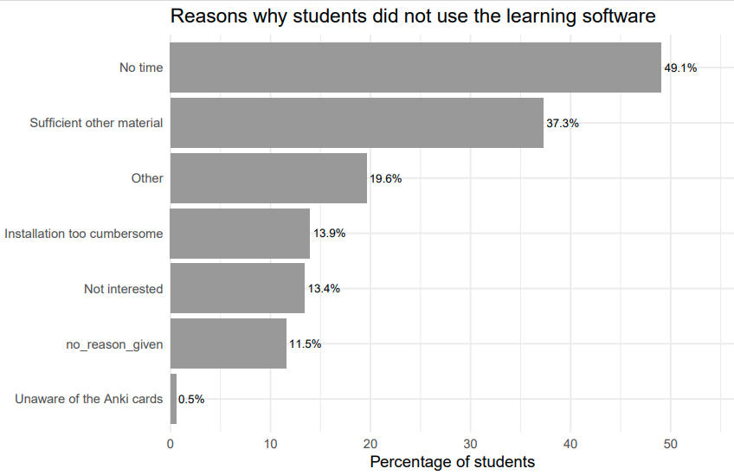
Figure 5. Reasons for not using Anki.

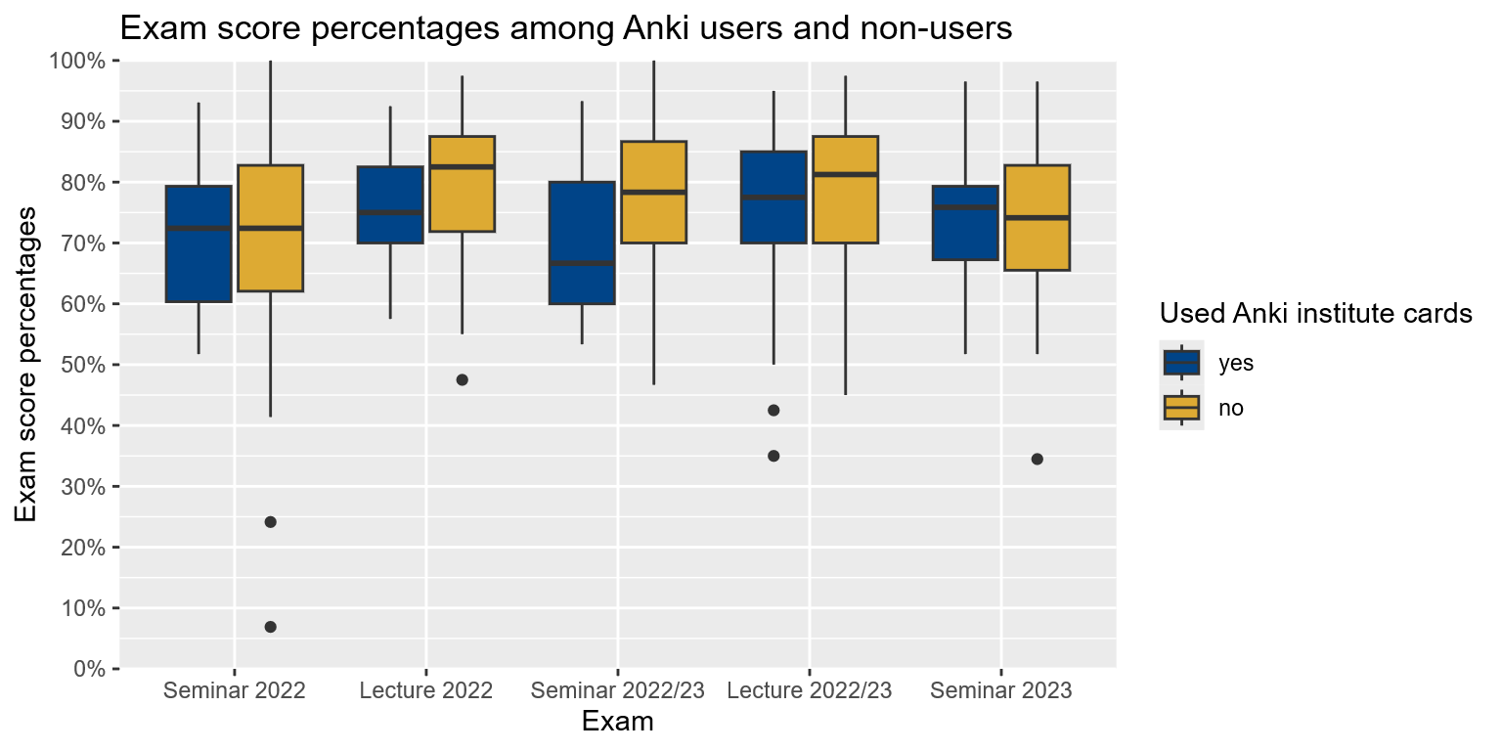
Figure 6. Anki usage and exam scores by cohort.

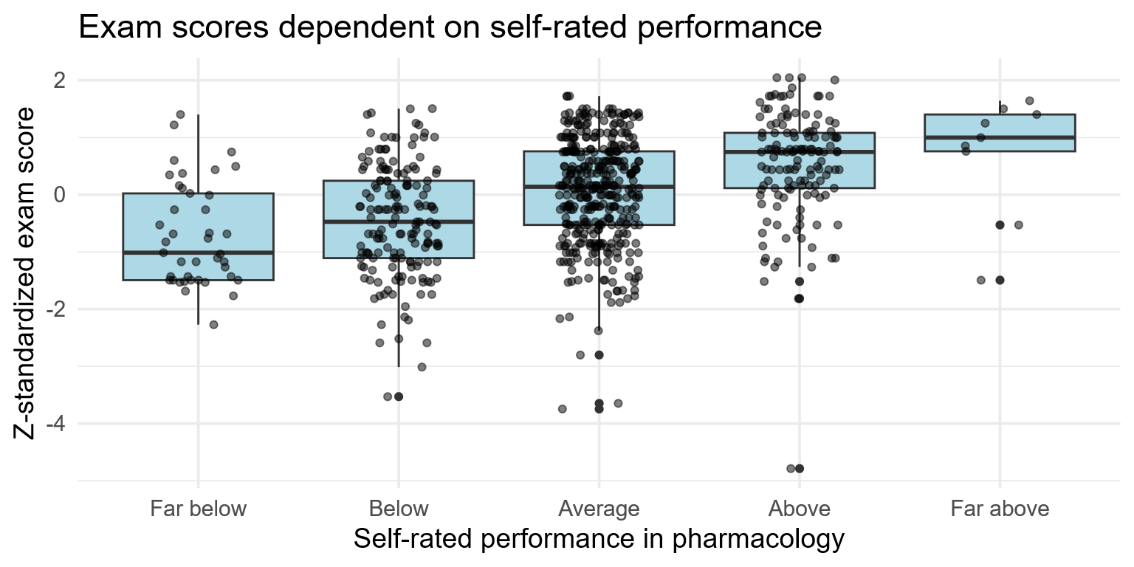

Figure 7. Relationship between self-rated academic performance and standardized exam scores.
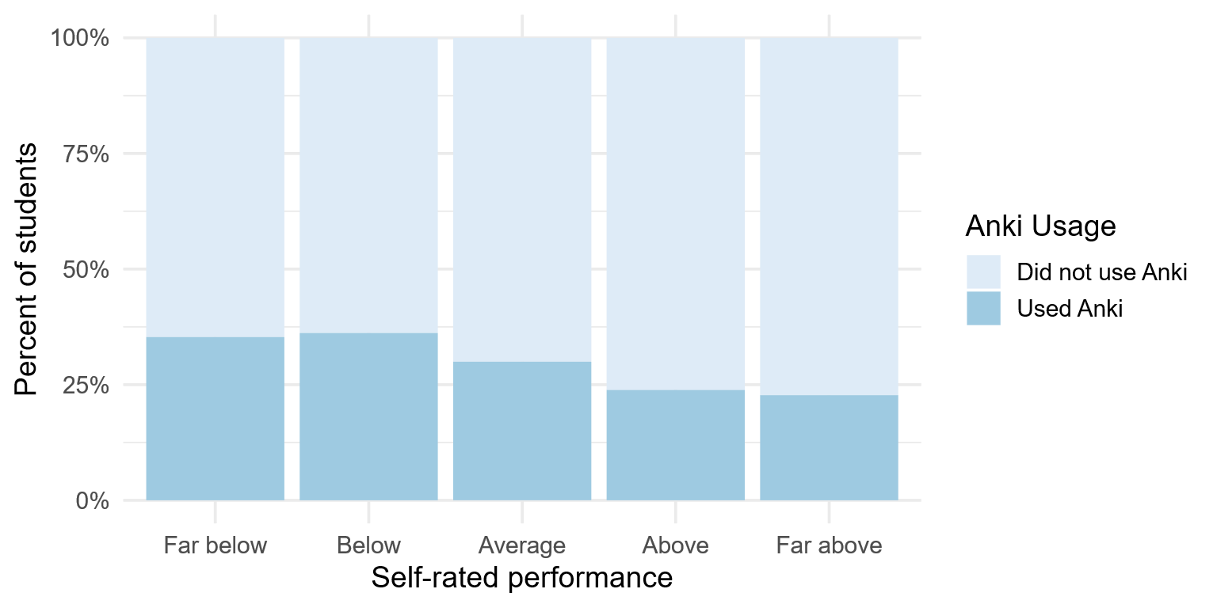
Figure 8. Self-rated performance and Anki usage.

Fehlt noch im Results-Teil:
- Signifikanter Unterschied zwischen Kategorien (z.B. lernten sign. Mehr Stud. mit den Karten für die Vorlesungsklausur als für die Seminarklausur?). Aber ist das überhaupt nötig zu untersuchen?
- Zeitaufwand Kartenerstellung
Conclusions
- Students showed a high response rate (90%) to the survey questionnaire
- Stu
- Anki cards were mainly used for studying for lecture, not seminar exam, perhaps since seminar exams are known to have a stronger focus on case miniatures
- No causality can be inferred since no randomization was done, observational study only. However, in reality students self-select their studying material as well, and a randomized study would have missed self-selection of lower-performing students for Anki.

